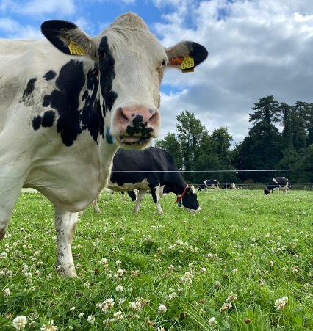
Project Objectives

- To develop a sustainable high-output grass-based spring milk production system
- To incorporate the most recent advances in grassland management for dairy farms into a high- output system
- Use a type of dairy cow that has good genetic indices for both milk production and fertility
- Employ the best practices from nutrition research and dairy cow husbandry
- Incorporate nutritional studies into a high-output system
- To incorporate management technologies and system attributes that enhance the sustainability of dairy production
Farm Details Week 18th– 24th Sept 2023
Stocking rate on MP (LU/ha) | 3.16
Farm Cover (kg of DM/ha) | 511
Growth Rate (kg of DM/ha/day) | 33
Demand (kg of DM/ha/day) | 32
Average grass DM (%) | 14.4
Average Concentrate fed (kg/day) | 3.3
Average DIM | 217
Cow Details Week 18th – 24th Sept 2023
Yield (kg/cow/day) | 21.7
Fat (%) | 5.16
Protein (%) | 3.82
MS (kg/day) | 1.95
SCC | 60,309

Grassland Management:
Farm cover has fallen to critical levels. On Tuesday 19th the feed budget was altered to 10 kg DM grass, 6 kg DM silage and 4 kg Concentrate to reduce demand for grass on the platform. Cows will be housed by night from Thursday 28 September to sustain some level of grass in the diet for an extended period of time. Due to the lower covers, grass quality has been excellent.

Comments:
With the introduction of silage at a higher exclusion level, milk production has taken a slight dip from last week as expected. However, milk solids are holding well at 1.95kgs/cow/day. From the same period last year, milk production was 20.3 kg/cow at 4.56% fat, 3.63 % protein (1.59 kg MS) and SCC was 50,000.

BCS was carried out on the 19th Sept with 55 cows being scored,
3 cows were 2.5 (5.5%)
17 were 2.75 (31%)
21 were 3 (38%)
14 were 3.25 (25.5%)

